**27th June, 2018.**

**The Facility Manager,**

**Shalom Apartment,**

**Ikoyi, Lagos.**

Dear Sir/Ma,

**INTRODUCTION LETTER**

It gives us immense pleasure and pride to introduce to you our company, **EPHRAIM TECHNOLOGIES NIG. LTD.**

**EPHRAIM Technologies Nig. Ltd.** is a company registered with the Cooperate Affairs Commission (CAC).

**EPHRAIM Technologies Nig. Ltd.** offers various services including sales and repair of Inverters, Uninterruptible Power Supply (UPS), Automatic Voltage Regulators (AVR), Solar Energy Systems, Elevators, Escalators, Electrical & Mechanical Designs and general supplies.

Please note that we also specialize in carrying out electrical audit/troubleshooting both for domestic and Industrial.

We are a team of highly enthusiastic, energetic and tech savvy engineers. The strength of our company lies in the rich multinational experience of its people, who come from diverse background.

We are NEW. We are DIFFERENT. We are here to SERVE YOU BETTER.

Thank you in advance for your anticipated response.

Yours faithfully,

Who we are: We are a team of highly enthusiastic, energetic and tech savvy engineers. The strength of our company lies in the rich multinational experience of its people, who come from diverse background.

**Products:**

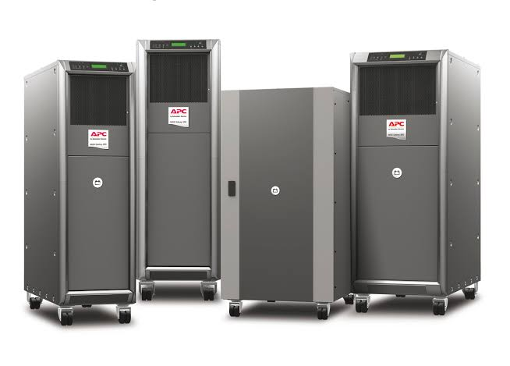

**Galaxy 300 (30kVA)**

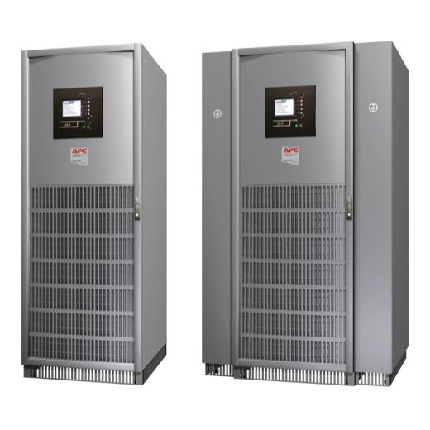

**Galaxy 5000 (40kVA)**

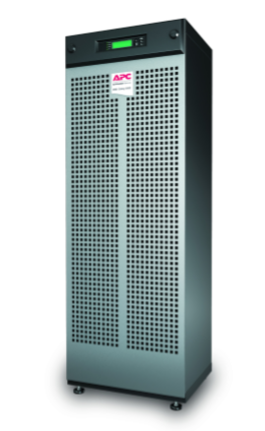

**Galaxy 3500 UPS**

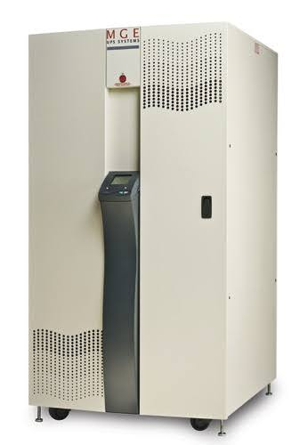

**Galaxy 3000**

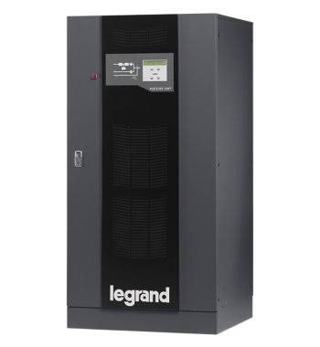

**Legrand UPS**

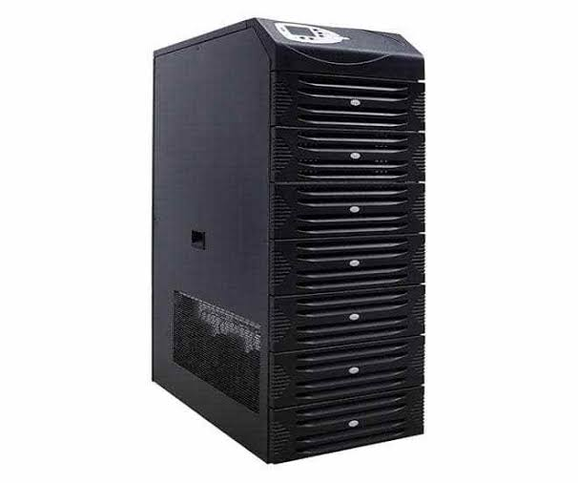

**Elen UPS**

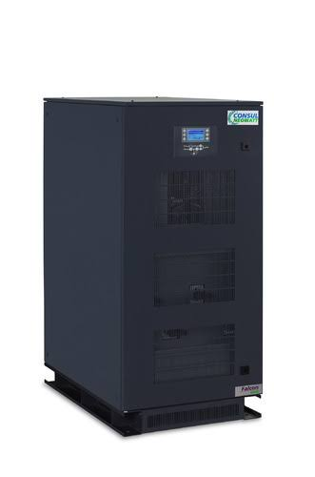

**Falcon UPS**

**Clients**











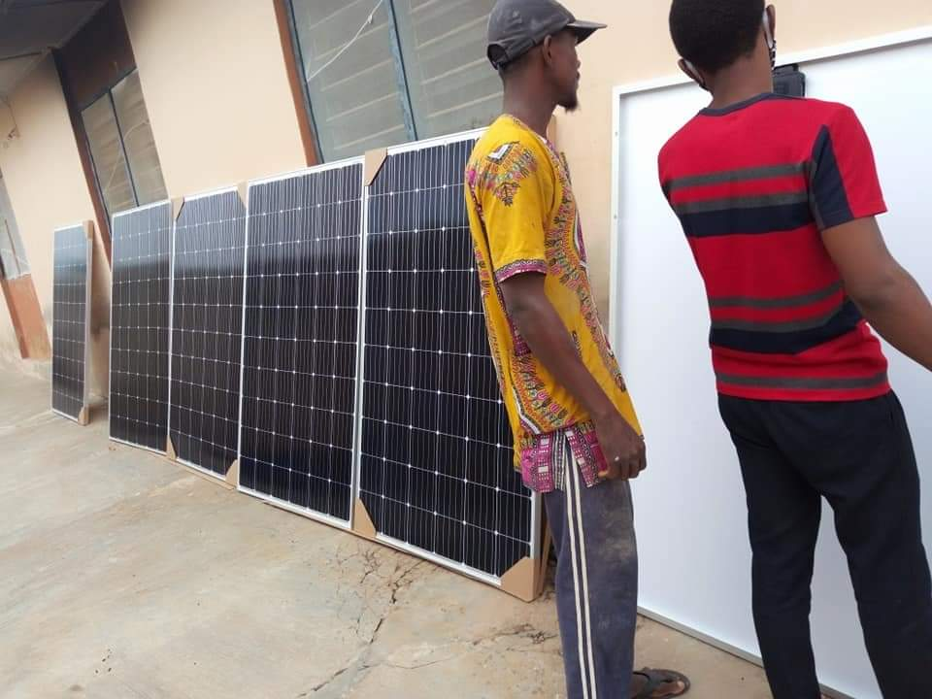

**Installation of new solar panels at Iseyin, Oyo State, Nigeria**

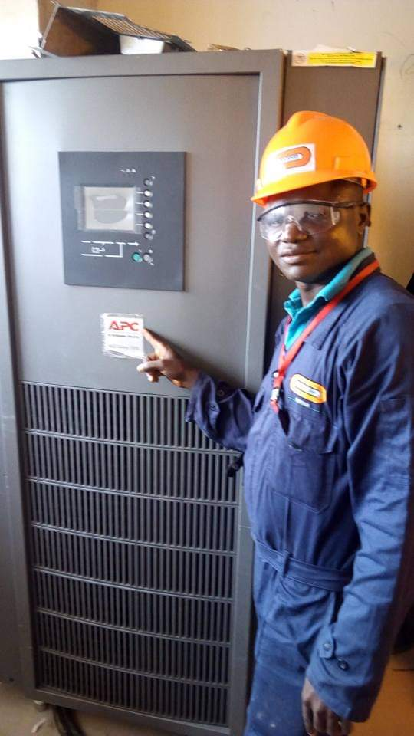

**Installation of a 40kva galaxy 5000 UPS at Novotel Hotel, Port-Harcourt.**

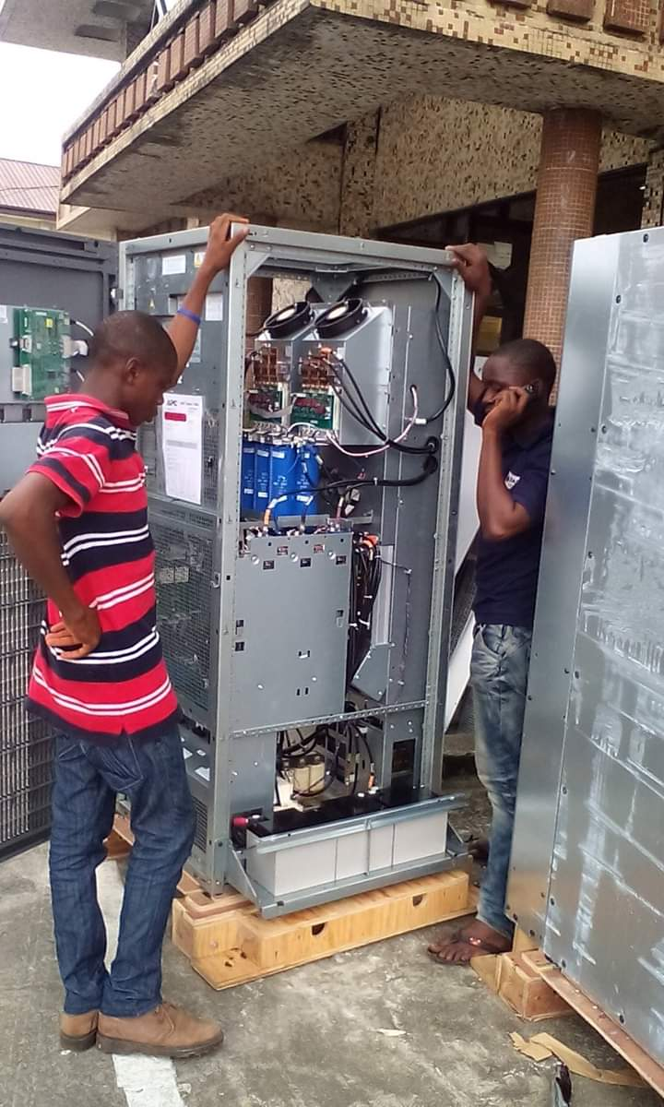

**Installation of Galaxy 5000 UPS, PH.**

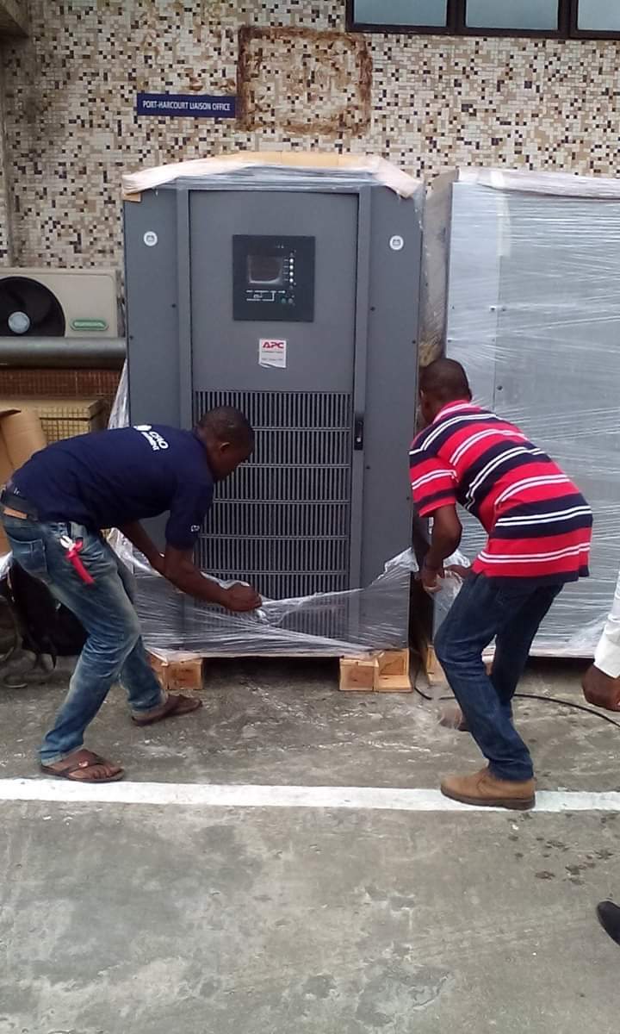

**Installation of Galaxy 5000 UPS, PH.**



Logistics of 100kva UPS APC UPS to Benin

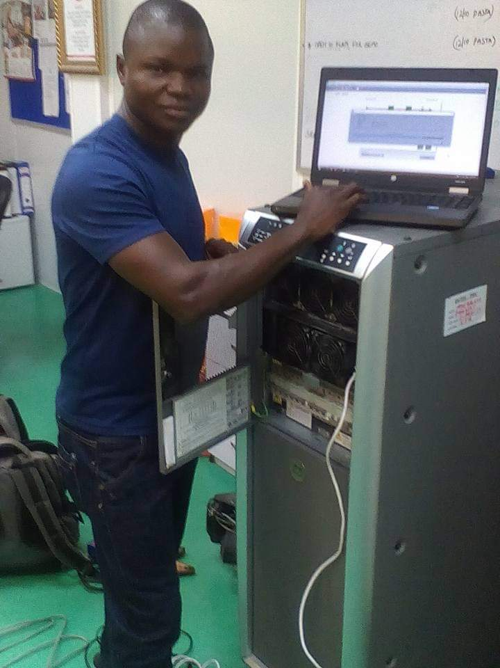

Programming of Galaxy 300 30kva UPS at Pure Flour Mills, PH.

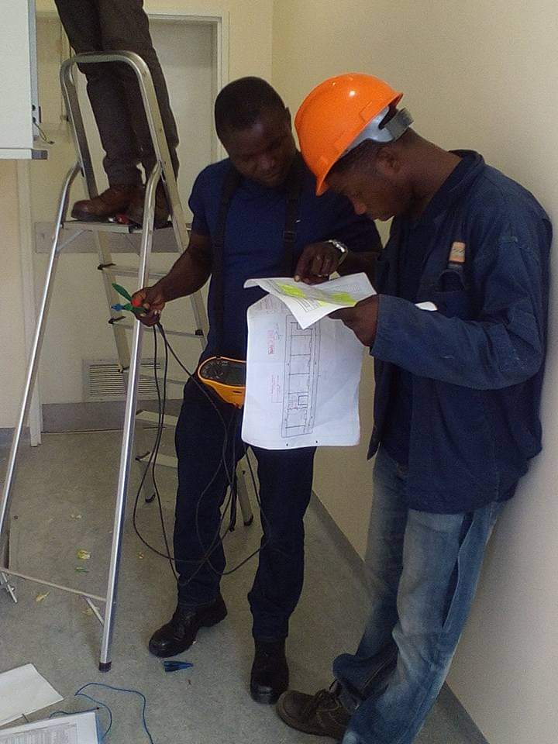

Installation at NLNG, Bonny Camp, PH.

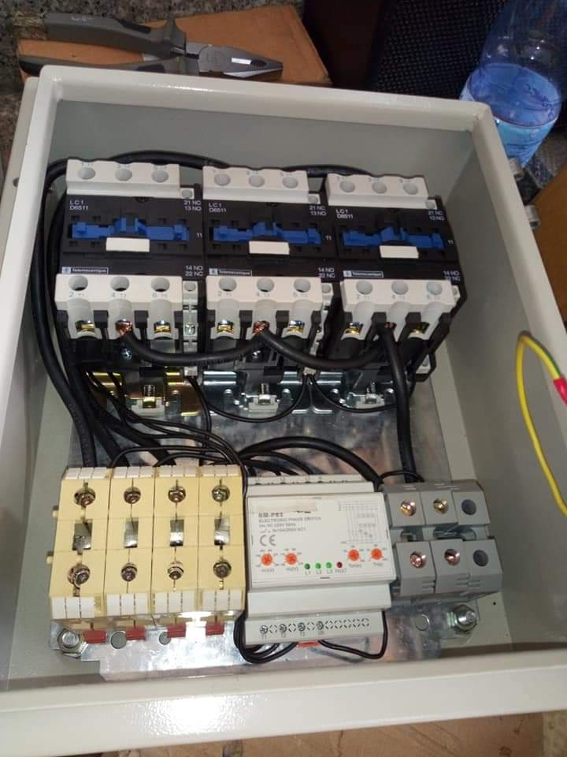

Construction of a phase reversal panel (3-ø)

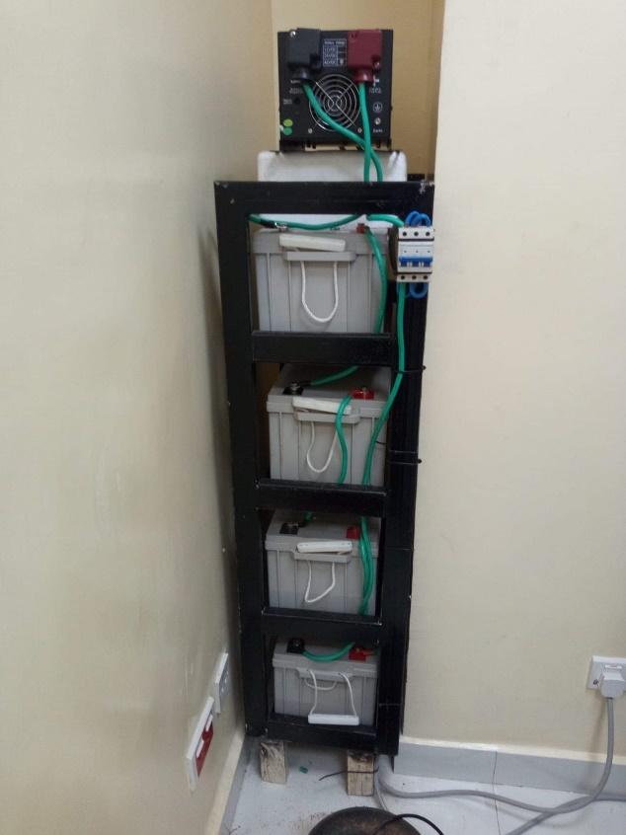

Installed 5kva/48VDC Inverter at ILO Consult, Ikeja.